**Dr. Prabhakara Rao Ganji**

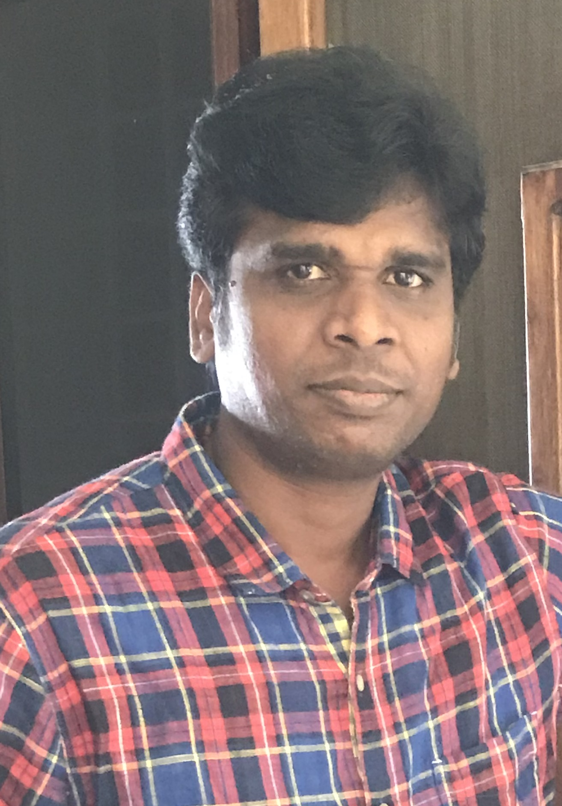

**A 304, Ganesh Royal Cruise Apartments**

**Near Gowtham School Gudivada**

**Gudivada, Krishna District**

**Andhra Pradesh, India 521301.**

[ganjiprabhakar@gmail.com](mailto:ganjiprabhakar@gmail.com)

Mobile: +91 8332877053

[**linkedin.com/in/dr-prabhakar-rao-09671a193**](https://www.linkedin.com/in/dr-prabhakar-rao-09671a193)

**Profile:**

Creative and passionate teacher dedicated to fostering a student-centered classroom environment based on mutual respect and collaboration. Committed to helping students identify and develop their own passions while becoming successful, confident writers.

**Educational Qualification**

**National Institute of Technology, Warangal**

Ph.D. in Mechanical Engineering **(Thermal)**  July 2013 - June2018

**Thesis Title:**

Parametric Optimization of Direct Injection CI Engine To Achieve HCCI Combustion Characteristics for Diesel/Biodiesel Blends

**National Institute of Technology, Calicut**

M.Tech in Industrial Engineering and Management with **First Class** July 2007-June 2009

**V R Siddhartha Engineering College, Vijayawada**

B.Tech in Mechanical Engineering with **First Class**  Aug 2002- June 2006

**Teaching Experience Total:14 Years (10 +04)**

**Associate Professor**

**Gudlavalleru Engineering College Andhra Pradesh.** 23 October 2019 to Till date

**Adhoc-Faculty**

**NIT Andhra Pradesh** 21stAugust 2017- 31st May2019

**Assistant Professor**

LN B C Institute of Engineering and Technology, Satara 7th July 2010 – 31stMarch 2013

**Assistant Professor**

Gokul Institute of Technology and Sciences, Bobbili 23rdJuly 2009 – 30thJune 2010

**Teaching Assistant/Research Experience Total: 04 Years**

Worked as a full time research scholar in the department of Mechanical Engineering in **National Institute of Technology, Warangal (Under TEQIP II COE)** July 2013 – August 2017.

**Software Skills**

CONVERGE for simulations

Ensight for post processing

Modefrontier for optimization

**Teaching Interests**

* Internal Combustion Engines
* Alternative Energy Sources
* Optimization Techniques
* Heat Transfer
* Industrial Management

**Publications (12 SCI+ 5 SCOPUS)= 17**

1. Ganji, Prabhakara Rao, Kiran Prasad Chintala, VR K. Raju, and Srinivasa Rao Surapaneni. "Parametric study and optimization using RSM of DI diesel engine for lower emissions." Journal of the Brazilian Society of Mechanical Sciences and Engineering 39, no. 3 (2017): 671-680. (**SCI)**
2. Ganji, Prabhakara Rao, V. Rajesh Khana Raju, and S. Srinivasa Rao. "Computational optimization of biodiesel combustion using response surface methodology." Thermal Science 21 (2017): 465-473. (**SCI)**
3. Chowdary, P. Kashyap, Prabhakara Rao Ganji, M. Senthil Kumar, C. Ramesh Kumar, and S. Srinivasa Rao. "Numerical analysis of CI engine to control emissions using exhaust gas recirculation and advanced start of injection." Alexandria Engineering Journal 55, no. 2 (2016): 1881-1891. **(SCI-Elsevier)**
4. Ganji, Prabhakara Rao, RudraNath Singh, V. R. K. Raju, and S. Srinivasa Rao. "Design of piston bowl geometry for better combustion in direct-injection compression ignition engine." Sādhanā 43, no. 6 (2018): 92. **(SCI)**
5. Ganji, Prabhakara Rao, ViswanathKummara, V. R. K. Raju, and Srinivasa Rao Surapaneni. "Effect of Early Injection Combined with EGR on Combustion Characteristics of Pongamia Biodiesel Blend." Proceedings of the National Academy of Sciences, India Section A: Physical Sciences: 1-6. **(SCI)**
6. Kattela, Siva Prasad, Rajesh Khana Raju Vysyaraju, Srinivasa Rao Surapaneni, and Prabhakara Rao Ganji. "Effect of n-butanol/diesel blends and piston bowl geometry on combustion and emission characteristics of CI engine." Environmental Science and Pollution Research 26, no. 2 (2019): 1661-1674.**(SCI)**
7. Prabhakara Rao Ganji.Kattela, Siva Prasad, Rajesh Khana Raju Vysyaraju, Srinivasa Rao Surapaneni, and “Parametric optimization of direct injection CI engine to improve combustion characteristics” Environmental Progress and Sustainable Energy. (**SCI**)<https://doi.org/10.1002/ep.13494>.
8. Rao, Ganji Prabhakar, VipinDhyani, Deepak Kumar, V. R. K. Raju, and S. Srinivasa Rao. "Investigating optimal operating parameters of DI diesel engine: a CFD approach using CONVERGETM." World Journal of Engineering 13, no. 4 (2016): 356-363.**(ESCI)**
9. Ganji, Prabhakara Rao, Al-Qarttani Abdulrahman Shakir Mahmood, AasrithKandula, Vysyaraju Rajesh Khana Raju, and Surapaneni Srinivasa Rao. "Parametric Optimization Through Numerical Simulation of VCR Diesel Engine." Journal of The Institution of Engineers (India): Series C 98, no. 4 (2017): 485-491. **(SCOPUS)**
10. Alumkal, Christiansun Antony, G. Prabhakara Rao, and V. Madhusudanan Pillai. "Analysis of robust and adaptive designs for dynamic part population." International Journal of Business Performance and Supply Chain Modelling 3, no. 2 (2011): 124-140. **(SCOPUS)**
11. Ganji, Prabhakara Rao, KashyapBabuChowdaryPutta, Siva Prasad Kattela, V. R. K. Raju, and S. Srinivasa Rao. "Optimisation of EGR and SOI for better combustion characteristics using response surface methodology." International Journal of Ambient Energy (2019): 1-10.**(ESCI)**
12. Ganji, Prabhakara Rao, Raju, V. R. K., and S. Srinivasa Rao. "Effect of fuel injection pressure and spray cone angle in DI diesel engine using CONVERGETM CFD Code." Procedia Engineering 127 (2015): 295-300.
13. Babu, J. M., Kattela Siva Prasad, Prabhakara Rao Ganji, ChRavikiran, and R. Velu. "Analysis on the effect of pilot injection strategies on combustion and emission characteristics of palm-munja biodiesel/diesel blend on CRDI diesel engine." International Journal of Ambient Energy (2019): 1-4.**(ESCI)**
14. Ganji, Prabhakara Rao, et al. "Enhancement of combustion characteristics of VCR diesel engine by optimizing engine parameters." *SN Applied Sciences* 3.8 (2021): 1-13. **Scopus**
15. Nageswara Reddy Pereddy,Tarun Dittakavi,Prabhakara Rao Ganji,Ranga Babu JA"Air-argon combined cycle gas turbine engine with water injection" ." Journal of The Institution of Engineers (India): Series C . **(SCOPUS) (accepted).**
16. Reddy, Pereddy Nageswara, Prabhakara Rao Ganji, and T. Narasimha Suri. "A Novel PCM Cold Energy Storage System for Reducing the Power Consumption of Air-Conditioning Unit and Shifting the Daily Energy Peaks to Off-peak Hours." *Journal of The Institution of Engineers (India): Series C* (2023): 1-8. **(SCOPUS)**
17. Venkatesh, V. S. S., Ganji Prabhakara Rao, Lokeswar Patnaik, Nakul Gupta, Sunil Kumar, Kuldeep K. Saxena, B. D. Y. Sunil, Sayed M. Eldin, and Fatima Hiader Kutham Al-kafaji. "Processing and evaluation of nano SiC reinforced aluminium composite synthesized through ultrasonically assisted stir casting process." *Journal of Materials Research and Technology* 24 (2023): 7394-7408.

**Conferences**

1. G.Prabhakara Rao, Vipin Dhyani, Deepak Kumar, V.R.K.Raju, S.S.Rao. Numerical investigation of the effect of compression ratio on the performance of direct injection diesel engine.5th international and 41st national conference on Fluid Mechanics and Fluid Power, IIT Kanpur12th to 14th Dec 2014.
2. G.Prabhakara Rao, Arun Raj, Rudranath Singh,V.R.K.Raju, S.S.Rao "Numerical investigation of split injection on pongamia bio diesel blend". 2ndInternational Conference on Thermal, Energy and Environment March 25&26, 2016.
3. Vipin Dhyani, Deepak Kumar, Prabhakar Rao, V. R. K. Raju, S. S. Rao. Numerical Experiment of CI Engine Combustion Using CONVERGE Software.National Conference On Fire Research and Engineering. FIRE 2014,IIT Roorkee.11-12th March 2014.
4. Prabhakara Rao, Siva Prasad, V. R. K. Raju, S. S. Rao. Numerical Investigation on the Effect of Overall Equivalence Ratio on Combustion Characteristics of DI CI Engine. NSMERS 2016, 7th Oct,2016.
5. Prabhakara Rao, V. R. K. Raju, S. S. Rao. “Prediction of Physical Properties for Pongamia Biodiesel used for Combustion Modeling International Conference on Recent Trends in Engineering, Science and Technology 2016, 1 June 2016, Hyderabad, India.
6. Prabhakara Rao, AVSS Hemanth, V. R. K. Raju, S. S. Rao “Effect of C.I. Engine Downsizing on combustion and enhancement of combustion characteristics of Downsized C.I. Engine" for the NCICEC 2019, NIT Kurukshetra.
7. Kashyap Babu Chowdary Putta, Prabhakara Rao Ganji, K. Nagaraju, P. Nageswara Reddy “Effect of start of injection and compression ratio on DICI engine using Pongamia biodiesel blend” ISBN: 978-1-5136-9400-9. Proceedings of Virtual International Conference On Research Contributions In Mechanical Engineering (ICRCME-2022), SRGEC-2022
8. Prabhakara Rao Ganji, P. Durga Naveen, P. Nageswara Reddy, B. Karuna KumarComputational Investigation of Diesel Injection Strategies in Hydrogen Diesel Dual Fuel Engine ISBN: 978-1-5136-9400-9. Proceedings of Virtual International Conference On Research Contributions In Mechanical Engineering (ICRCME-2022) , SRGEC-2022
9. P. Nageswara Reddy, T. Narasimha Suri, G. Prabhakara Rao. A Novel PCM-Cold Energy Storage System for Air Conditioning Energy Saving and Shifting of Daily Energy Peaks to Off-peak Hours ISBN: 978-1-5136-9400-9. Proceedings of Virtual International Conference On Research Contributions In Mechanical Engineering (ICRCME-2022),SRGEC-2022

**Workshops / Summer Schools Attended:**

1. National workshop on Competitive Manufacturing Management, NITCalicut, February 26, 2009.
2. AICTE-MHRD faculty development program on Management Research Methodology, at NITCalicut from 10-15 June 2013.
3. A Five-day workshop on “Scientific computing with MATLAB” at NIT Warangal from 22-26 September 2013.
4. Three day National workshop on Advances in Computational Fluid Dynamics: Methods and Applications at NIT Warangal from 17 to 19 October 2013.

**Workshops / Summer Schools Conducted:**

1. Worked as a coordinator for NSMERS 2016 at National Institute of Technology Warangal.

**Teaching and Research Plan for Next Three Year:**

I will strive to nurture the students to create jobs in the field of technology development. I will also encourage students in cocircular activities. My Research will be in the area of energy utilization and optimization. The aim of my research is to create/develop energy efficient systems in order to achieve patentable technology. I will contribute to the institute growth by putting constant efforts in developing teaching and research methods . My area of research would not stick to any particular topic and I will adopt my research based on present research problems related to energy and optimization.I will try to complete atleast 1 sponsored projects in the next three years.

I declare that the above-listed information is true to the best of my knowledge and that I will be responsible for any deviation from the truth of these facts.

**(PRABHAKARA RAO GANJI)**